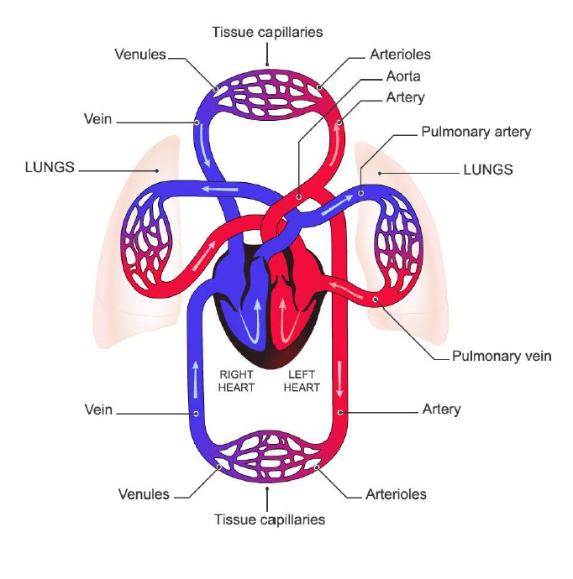Lecture 6 – Bionic Hearts

PART 1 – Cardiovascular physiology (not examinable)

* Purpose
  + Transports oxygen to body cells and takes away carbon dioxide (mainly)
  + Regulates body temperature and water content of cells
  + Carries white blood cells and antibodies to protect against disease
* Circulation
  + Left Heart has oxygen-rich blood
    - Pumps blood into aorta (largest vessel) out of left ventricle
    - Blood Collarbones limbs + legs
    - Blood aortic arch brain and body (eg. Kidney and guts)
  + When blood moves, blood vessels get smaller
    - Largest = aorta
    - Smallest = tissue capillaries
    - Oxygen leaves blood for tissues, while CO2 leaves cells into blood
  + Blood in vena cava Right heart
    - No oxygen in right heart, since all gone to cells
    - REPEAT: Pumps deoxygenated blood to lungs to pick up oxygen and drop CO2, and returns to left heart
  + 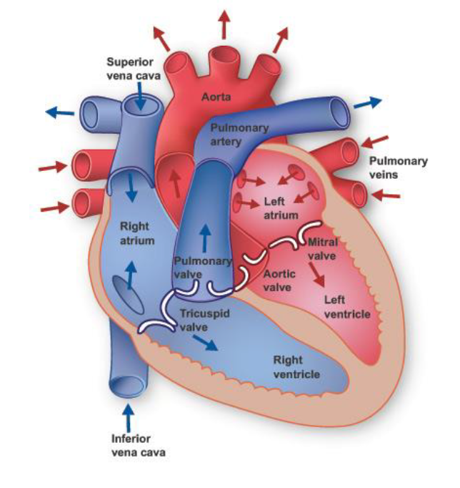Ventricles = main driving force
    - Left Ventricle bigger than right ventricle
      * 5-10x more energy, more pressure
      * More skin on outside, so muscles squish more blood out
  + Atria/atrium
    - Collects blood before it goes into ventricles
    - Right atrium receives deoxygenated blood from veins
    - Left atrium oxygenates blood from pulmonary veins
  + Heart has 4 valves
    - Blood is one-directional
    - Heart is pulsatile (relaxes and contracts), to continue flowing blood
  + Question: What happens to pressure and flow in systemic circulation when the left ventricle fails? (see pic)
    - Flow and pressure goes down
    - Less force, less energy
    - Min flow rate/pressure to allow blood to into tissue
  + Question: What happens to pressure and flow in pulmonary circulation when the left ventricle fails? (see pic)
    - Pressure rises as right heart pumps strongly
    - Accumulation of blood, since left heart does not function
  + Question: Do you think that the body compensates for LV heart failure? Yes/No?
    - Yes
    - Needs to maintain cardiac output (amount of blood pumped/min) and RAP (blood pressure of right atrium)
    - Heart beats faster to maintain attempts to gain oxygen in heart increase muscle mass (due to overwork) heart enlargement
* Heart Disease
  + Causes: dysfunctional heart valves, virus, birth defects or coronary artery disease (damage in heart’s blood vessel)
  + Heart has to be alive when taken out (eg. On life-support) Not-enough donors

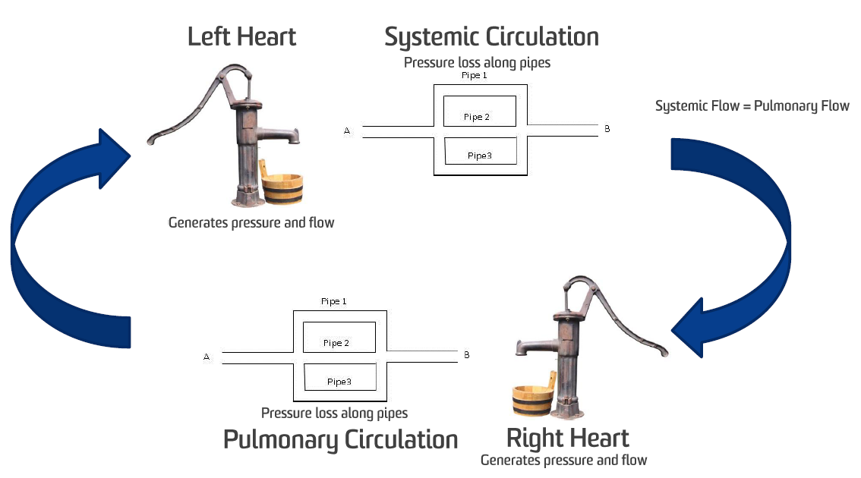PART 2 – Mechanical Therapy (Examinable)

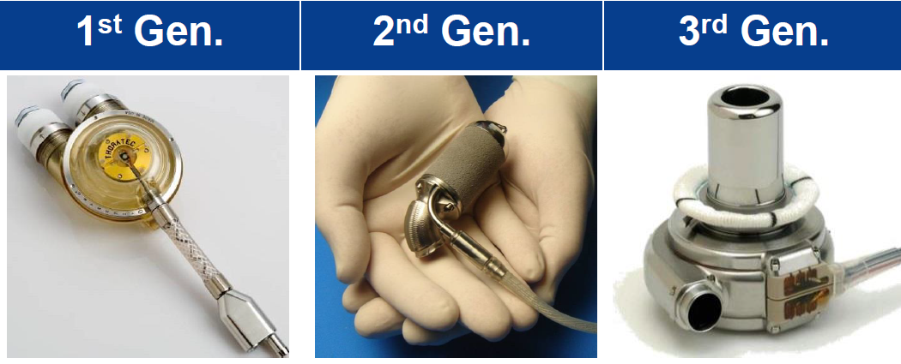

* Ventricular Assist Devices (VADs) supports failing ventricles
  + 1st Gen
    - Tried to mimic heart
    - Pneumatic (air or pressurized gas)/electric
    - Sits outside of body (usually)
      * Can see blood going in and out
      * Connected to large air compressor lack mobility poor quality of life
      * Very uncomfortable
    - Prone to infection, especially around tube gap into body
    - Potential to create blood clots in valves
    - Provide short term support
    - Aged out in developed countries because of poor functionality
  + 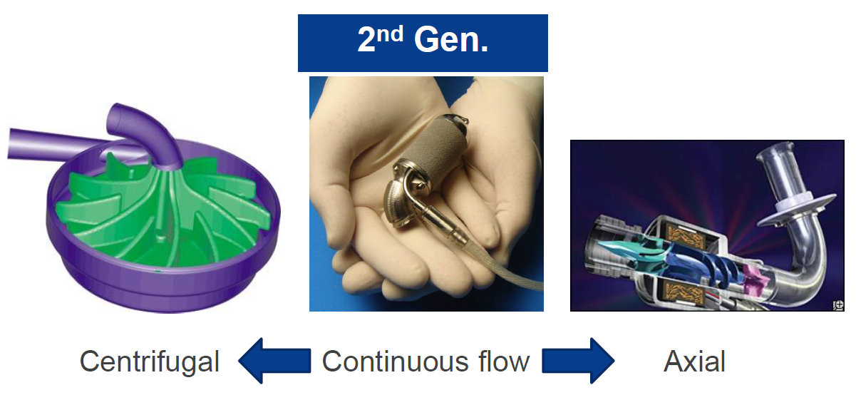2nd Gen
    - Adapted a more continuous air flow; centrifugal or axial
    - Longer support (approx. 8 years) compared to 12-24 months
    - Steady decrease of survival over prolonged time
    - Small – sized more mobility
    - Electronically driven
      * No pump = no air compressors
      * Less power requirements
    - Disadvantages:
      * Mechanical contact formation of blood clots
        + Goes through impeller breaks it loses functionality
        + Size Growth jams impeller VAD breaks down
        + Goes through untouched travels to patient’s brain death
      * 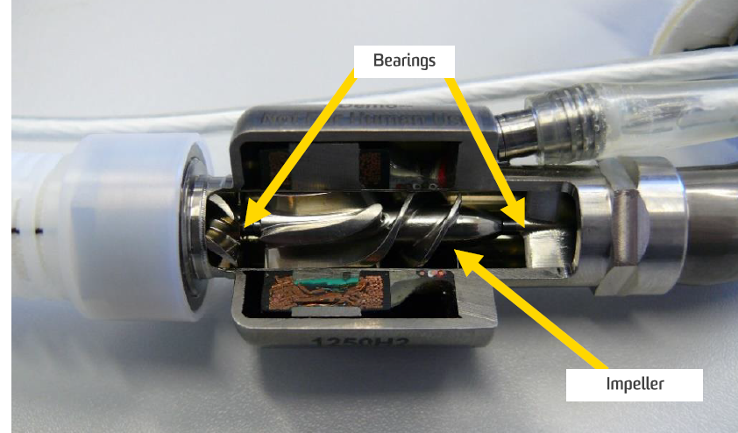Blood Damage
      * Infection
    - DESIGN:
      * Impeller = spiral disk
        + sucks blood and pushes it back out with higher flow rate
        + Needs bearing to spin
      * Thrust Bearing
        + Stop impeller from moving
      * Point of contact with bearings
        + Very high shear stress
        + Blood cells caught and torn to shreds
  + 3rd Gen
    - Continuous flow: axial + centrifugal
    - Completely implantable, with small cable exiting body
    - No mechanical wear impeller has no contact with any parts
    - DESIGN:
      * **Hydrodynamic** Bearings
        + Disk spins fast little slope on bottom generates lift force allows impeller disk to float above
        + High-pressure fluid (blood) underneath rotor
        + Rotor surfs on top of blood
        + 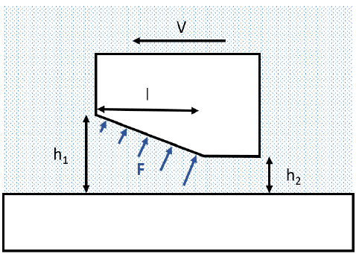Clearance (h = height between rotor/impeller and housing) needs to be large enough to prevent blood trauma
        + Small Clearance (h) required to generate pressure

Too big, won’t generate lift force

Blood is thick, so high shear rates can damage it

Clearance needs to be big enough to allow blood undamaged, but small enough to generate enough lift force to lift impeller off housing

* + - * + Changes in clearance requires change in speed or surface area
        + Min start-up speed required to maintain lift force

Not fast enough = drags impeller along casing damage blood cells

* + - * **Electromagnetic** bearings
        + Magnets on either side of the impeller suspends the impeller between them
        + Can do large gaps prevents blood cell damage
        + Magnets are large and bulky
        + More power than hydrodynamic
        + Requires additional sensors for control over rotor position
* General Complications wit VADs

1. Bleeding is biggest
   * Patients often take anti-clotting meds
   * Greater risk of death if they get a cut/graze
2. Infection

* Potentially due to trauma at exit site
  + Patient’s movement causes driveline (cable) to wiggle damage suture, etc.
  + Easier for bacteria to enter
* 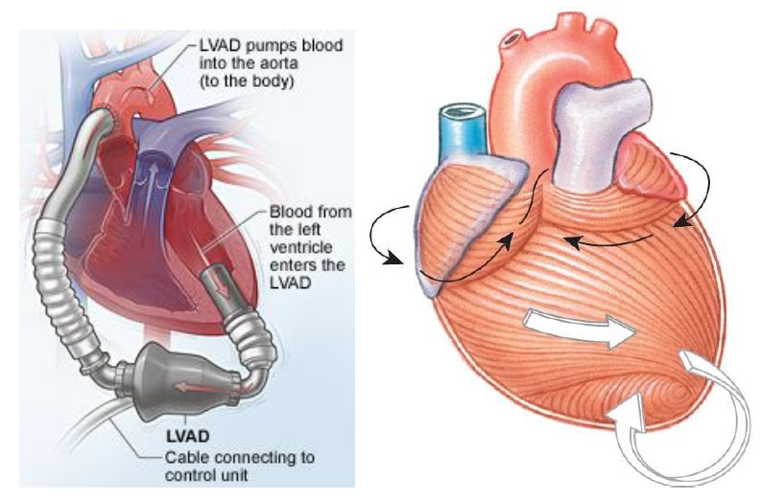Require daily monitoring and dressing changes
* Very difficult to treat
* Driveline design and coating can cause VAD infection
* Have tried transcutaneous energy transfer (wireless)

1. Right Heart failure (see right)
   * Right ventricle needs to keep up with left side
   * LVAD support, more common
   * Can use two 3rd gen LVAD’s, since Bivads have poorer survival rates
   * Cause respiratory failure
2. Neurological dysfunction
   * Due to thrombus (clots) forming in ventricle or LVAD
   * Important to optimize LVAD and ventricular flow dynamics
   * Cannula design reduces neurologic complications from ~23% ~4%
3. Cardiac Arrhythmia
   * Irregular heartbeat
   * Cause reduced blood flow, right heart failure, thrombus
   * Caused by cannula-heart interference
   * Heart can be sucked onto cannula by negative pressure created by LVAD

* Total Artificial Hearts (TAH)
  + Completely replaces the heart, ie. takes out heart and replaces completely
  + Used if:
    - Native heart cannot support life
    - Ineligible for transplant (ie. Not enough heart donors)
  + Large-sized; needs large patient
    - Some women and children ineligible
  + Similar principle to 1st Gen VADs
    - Pulsatile pump (with valves) connected to huge air compressor
    - Same disadvantages as 1st Gen VADS, ie. size or lack mobility
  + 2nd and 3rd Gen VADs
    - Whole heart taken out and replaced with turbines
    - No heartbeat continue flow
    - Worked on animals
    - 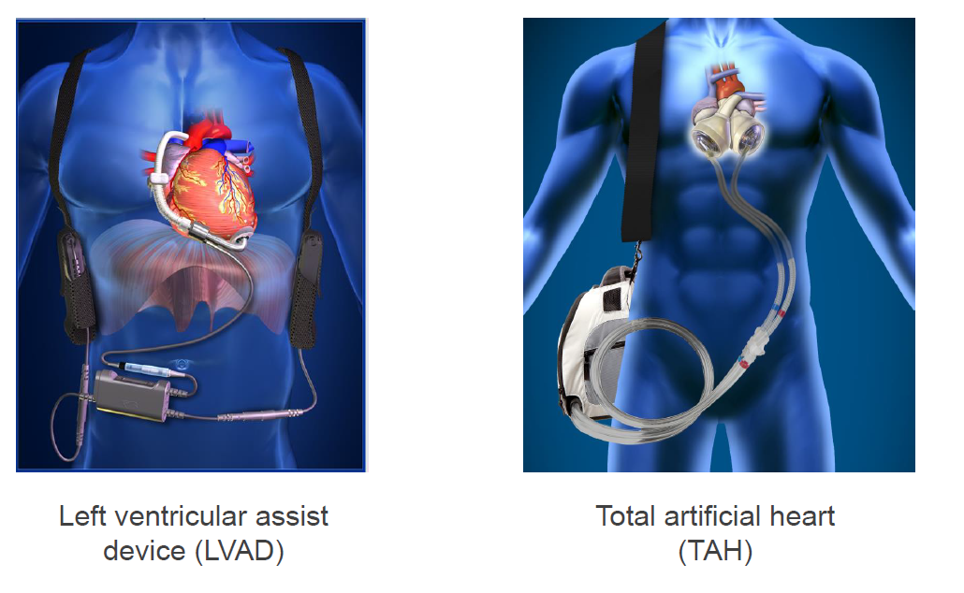Worked on first impromptu patient died soon after